Data Technician

Name: Slondiwe Mkhize
Course Date: 19/09/26

Table of contents
Day 2: Task 1 3
Day 3: Task 1 3
Exercise 1: Loading and Exploring the Data 4
Exercise 2: Indexing and Slicing 4
Exercise 3: Data Manipulation 4
Exercise 4: Aggregation and Grouping 5
Exercise 5: Advanced Operations 5
Exercise 6: Exporting Data 6
Exercise 7: If finished early try visualising the results 6
Day 4: Task 1 7
Day 4: Task 2 8
Course Notes 8
Additional Information 9

Day 2: Task 1

It is a common software development interview question to create the below with a certain programming language. Create the below using Python syntax, test it and past the completed syntax and output below.

FizzBuzz:

Go through the integers from 1 to 100.
If a number is divisible by 3, print "fizz."
If a number is divisible by 5, print "buzz."
If a number is both divisible by 3 and by 5, print "fizzbuzz."
Otherwise, print just the number.

Paste your completed work to the right | 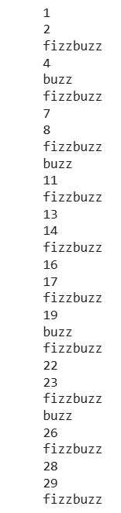  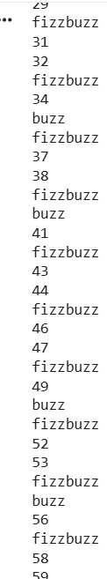  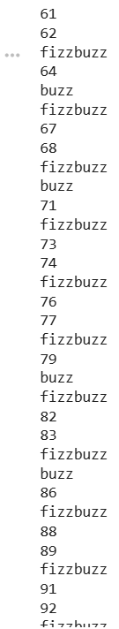  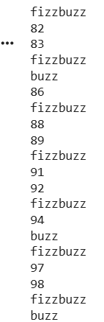  for number in range(1, 101):  if number % 3 == 0 and n % 5 == 0:  print("fizzbuzz")  elif number % 3 == 0:  print("fizz")  elif number % 5 == 0:  print("buzz")  else:  print(number)

Day 3: Task 1

Using the ‘student.csv’ which can be downloaded here, complete the below exercises as a group and paste your input and output. Although this is a group activity, everyone should have the below answered so it supports your portfolio:

Exercise 1: Loading and Exploring

1. Load Student.csv into a Pandas DataFrame called student_data.
2. Display the first 8 rows so you can check that the file has loaded correctly.
3. Find the number of rows and columns in the dataset.
4. Display the column names and data types.
Think like a Data Technician: Why would checking the shape and data types be useful before beginning an analysis?.

Answer : It is important before you start to analyse data to check the shape and data types because I will need to know what I am working with before I touch anything. The shape tells you how big the dataset is and how many rows I have and whether anything is missing. The data types tell you whether each column is in the right format, so I don’t end up trying to calculate averages on text or filter numbers that aren’t actually numbers. It’s a quick check that might save from messy surprises once I have started my analysis.

- Student_data = pd.read_csv(“student.csv”)
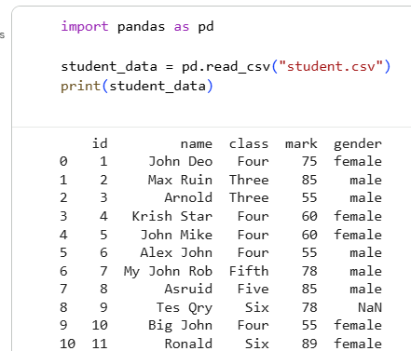

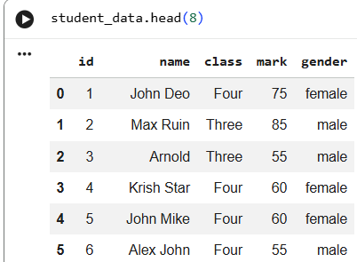

- student_data.head(8)

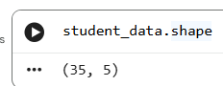
3.There are 35 rows and 5 columns.

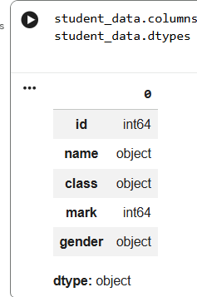
4.

Exercise 2: Indexing and Slicing
1. Display only the mark column.
2. Display the name, class and mark columns together.
3. Display the first 7 student records.
4. Display only students whose mark is greater than 70.
Interview question: Why might selecting only the required columns be useful when working with a large dataset?.
Answer: When working with a large dataset, selecting only the columns you need makes everything easier and neater to work with. It saves you time because you’re not dragging around unnecessary information, and you can focus on what actually matters. It also helps you work faster and reduces the chances of making mistakes that come from dealing with loads of extra columns you don’t even need.

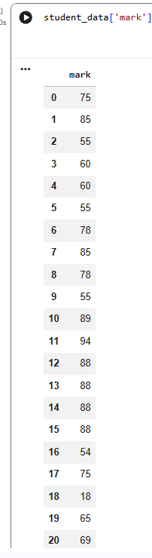
- student_data[mark]

- student_data[['name', 'class', 'mark']]
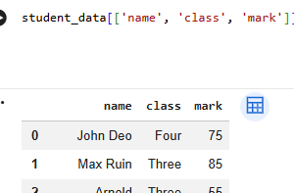
3. high_marks = df[df['mark'] > 70]
print(high_marks)
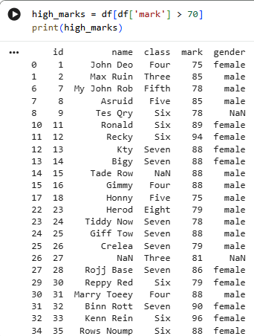

Exercise 3: Data Manipulation
1. Create a new column called high_score. The result should be True where a student’s mark is 75 or higher, and False otherwise.
2. Rename the name column to student_name.
3. Remove the high_score column after you have checked that it works.
Think back to Day 2: Where have you seen >= before this Pandas session, and what job is it doing here?
Answer: It will check to see if one number is greater than or equal to another and gives you a True or False output. So df['mark'] >= 75 is basically asking you “Is this mark 75 or above?” for every student, and then gives a True or False answer for each row.

- df['high_score'] = df['mark'] >= 75 ,print(df[['name', 'mark', 'high_score']])
- df = df.rename(columns={'name': 'student_name'}) print(df.head())
- df = df.drop(columns=['high_score'])
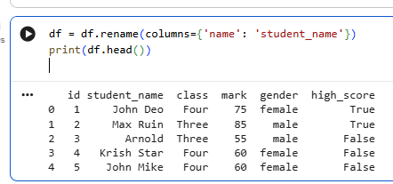

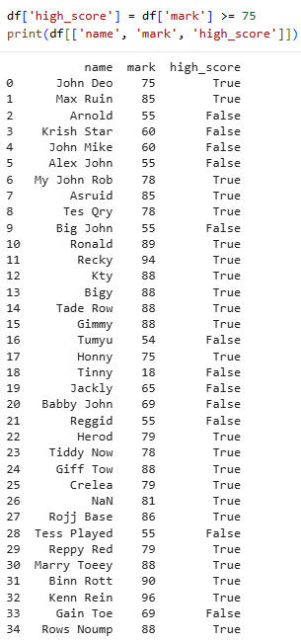
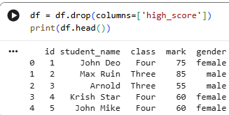

Exercise 4: Aggregation and Grouping
1. Calculate the average mark for each class.
2. Find the number of students recorded for each gender.
3. Find the highest mark achieved in each class.
Workplace question: Which result would be most useful if a manager wanted to compare class performance, and why?
Answer :The average mark for each class is the one a manager would actually use when comparing class performance. This gives a clear picture of how the whole class is doing and not just one top score or how many students are in the group. With the average, the manager can quickly see which classes are stronger and which are not and where support might be needed.

- average_marks = df.groupby('class')['mark'].mean() print(average_marks)
- gender_count = df['gender'].value_counts() ,print(gender_count)
- highest_marks = df.groupby('class')['mark'].max()

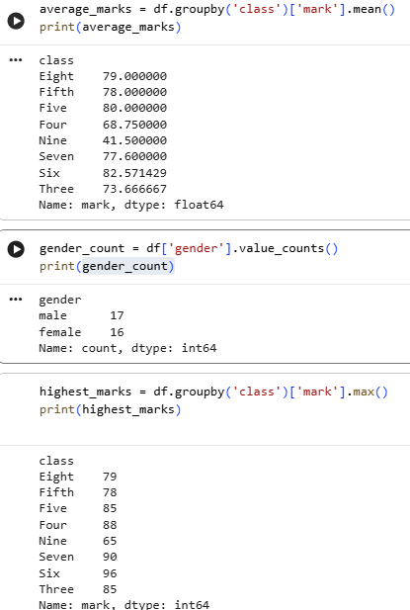

Exercise 5: Advanced Operations
1. Create a pivot table that shows Class as the rows, Gender as the columns, Mark as the values and the average mark within each combination. Explain what this helps a manager compare.
2. Create a new performance column with these bands: 80–100 = Excellent; 70–79 = Good; 60–69 = Satisfactory; below 60 = Needs Improvement.
3. Sort the student records by mark from lowest to highest.
Workplace question: Why might a manager deliberately sort from lowest to highest rather than highest to lowest?

Answer: Sorting marks from lowest to highest helps the manager quickly spot which students might need extra support. Starting at the bottom makes it easy to see which classes or students are struggling the most without scrolling through the whole table. It highlights the weak spots first, so nothing important gets missed before looking at the higher marks.

- pivot = pd.pivot_table( df, values='mark', index='class',columns='gender')
print(pivot). If this was a workplace task, the pivot table would quickly show how each gender is performing in every class, making it easy to spot which classes are stronger or weaker overall and highlight any patterns that need attention. It gives a clear overview of where things are going well and where support might be needed, all in one place

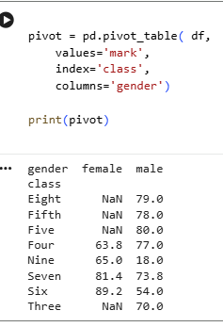
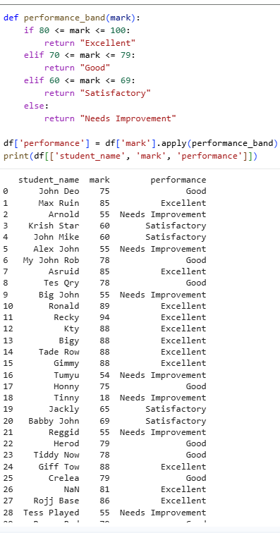
2.

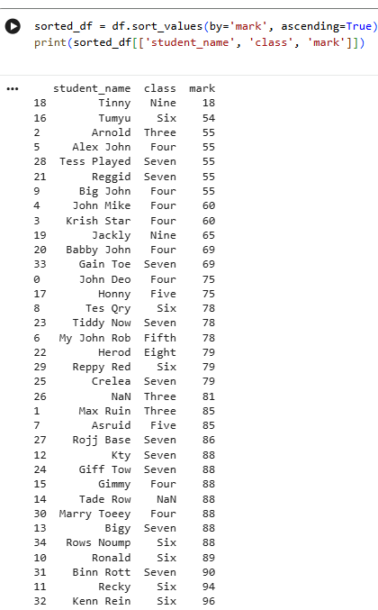

3.

Exercise 6: Exporting Data
- 1. Save your updated DataFrame as student_performance_report.csv and download the file from Google Colab.
- We haven’t done this in session so here is a hint *
Use the Pandas to_csv() method to save your updated DataFrame as student_performance_report.csv. Once the CSV has been created, download the file from Google Colab. If you are unsure how to download a file from Google Colab, search for the files.download() function.
- Workplace question: Why might exporting the finished results to CSV be useful when colleagues use Excel or another system rather than Python?

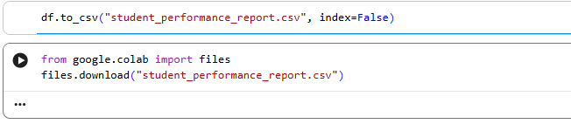
1.

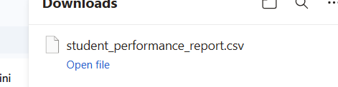
2.

3.Exporting to a CSV makes the work easy for everyone to use, even if they don’t work with Python. CSV files open in Excel, Google Sheets, databases, and most office systems, so your colleagues can view the results, sort or filter the data, add their own notes, or drop it straight into whatever tools they use. It’s basically a universal format that keeps your analysis flexible and easy to share across the whole team.

Rounded numbers make the chart look more professional and the printed output easier to understand.

Exercise 7: If finished early try visualising the results

1. Your manager asks: “Can you show me the average student mark for each class visually?” Create an appropriate chart with a meaningful title and clear axis labels. Explain why you chose that chart type.
Extra challenge: Create one additional visualisation using Student.csv. Before writing the code, write: “The question I want this chart to answer is…” Then create a visual that answers that question.

1.
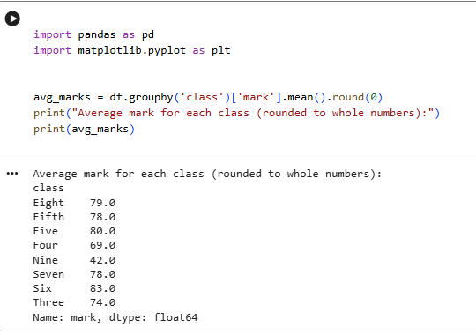
1.

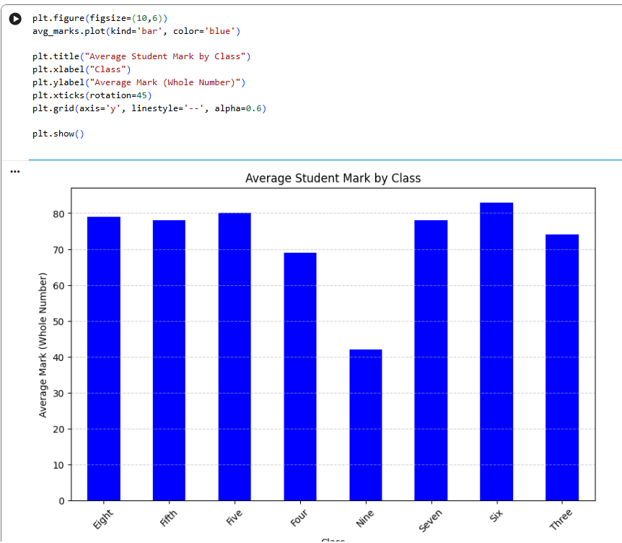
The bar chart will answer the question straight away you can quickly see which gender has the higher average mark. It’s clear and easy for the manager to understand without having to go through loads of numbers.

Extra Challenge:
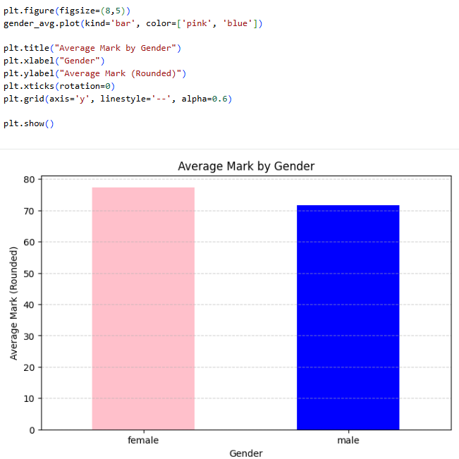
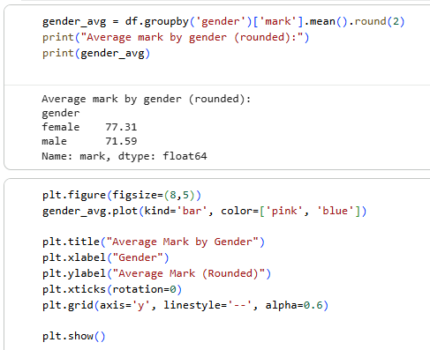

Also rounded the numbers to make the chart look more professional and the printed output easier to understand.

Day 4: Task 1

Using the ‘GDP (nominal) per Capita.csv’ which can be downloaded here, complete the below exercises and paste your input and output. Work individually, but we will work and support each other in the room.

- Read and save the ‘GDP (nominal) per Capita’ data to a data frame called “df” in Jupyter notebook
- Print the first 10 rows
- Print the last 5 rows
- Print ‘Country/Territory’ and ‘UN_Region’ columns

1.
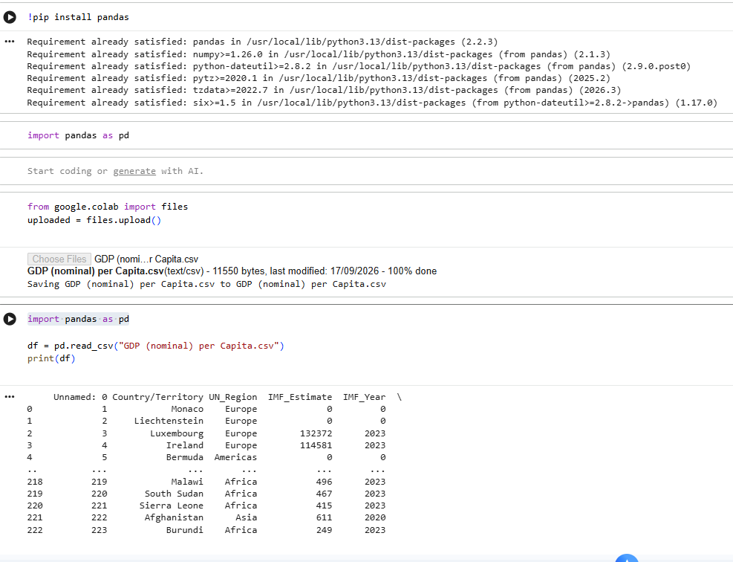

2.
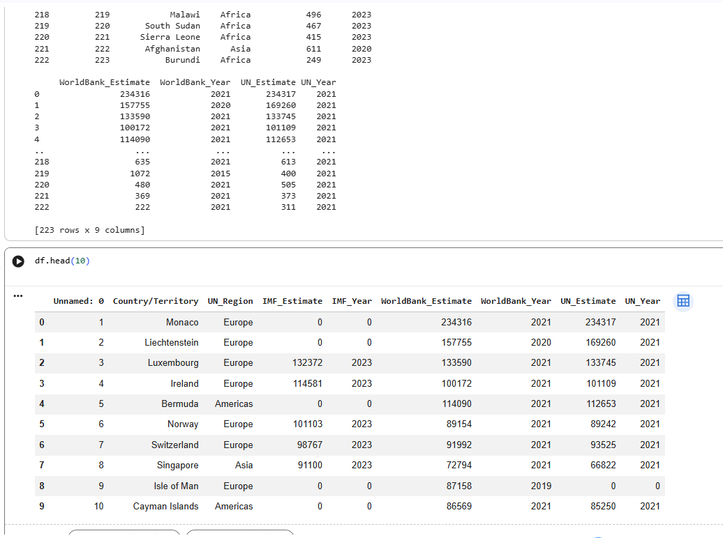

3.
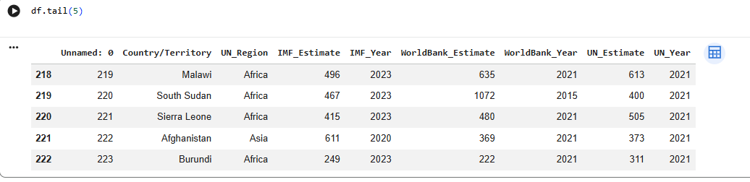
4.
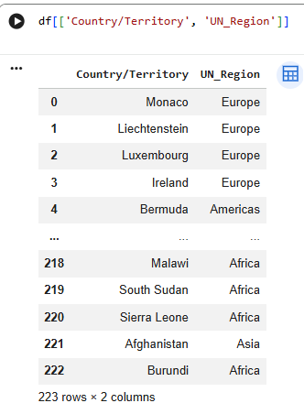

Day 4: Task 2

Back with ‘GDP (nominal) per Capita’. As a group, import and work your way through the Day_4_Python_Activity.ipynb notebook which can be found here. There are questions to answer, but also opportunities to have fun with the data – paste your input and output below.

Once complete, and again as a group, work with some more data and have some fun –there is no set agenda for this section, other than to embed the skills developed this week. Paste your input and output below and upon return we’ll discuss progress made.

Additional data found here.

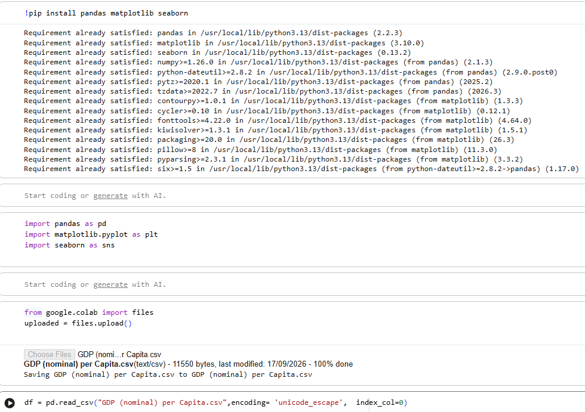
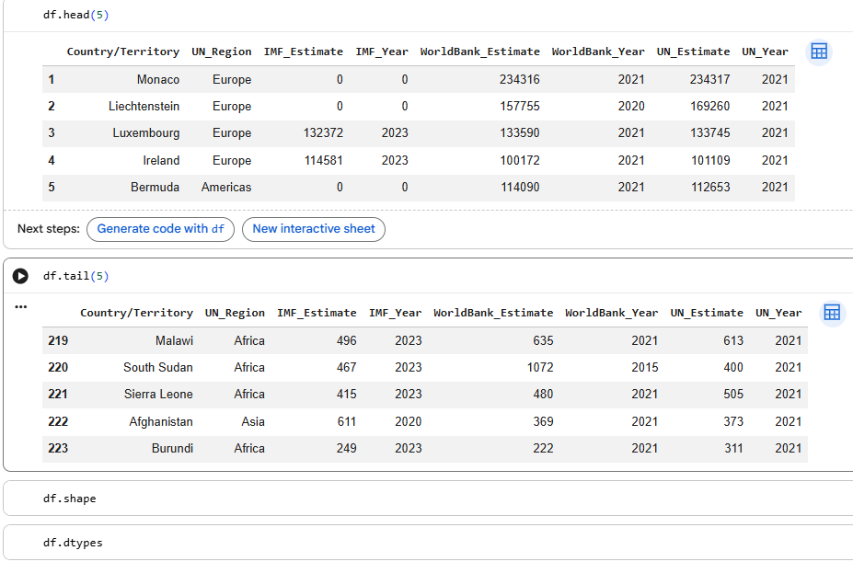

1.
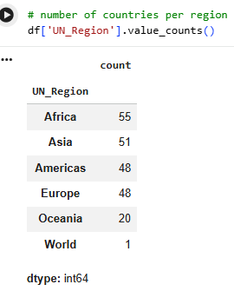

2.
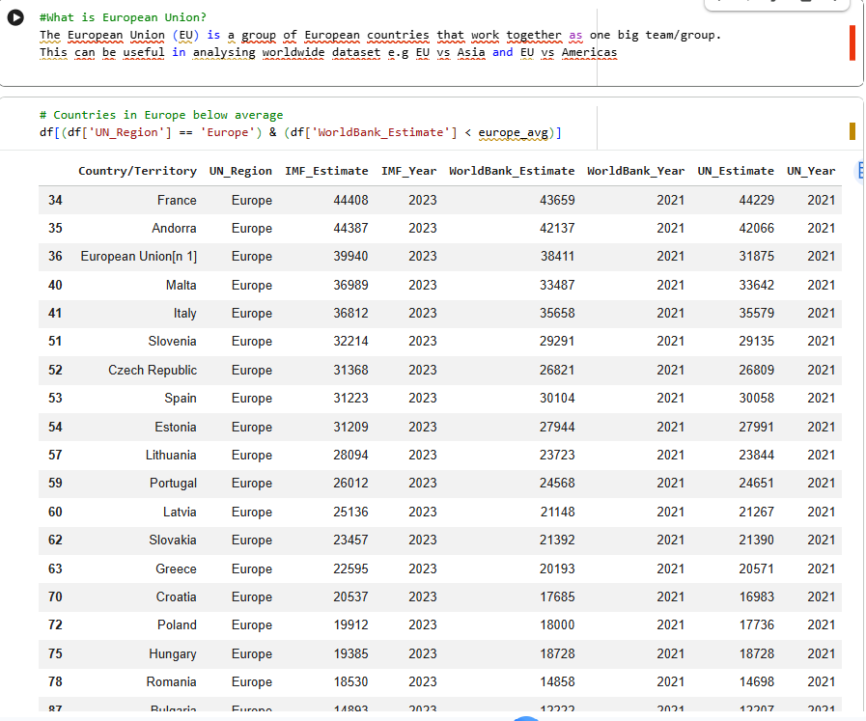

3.

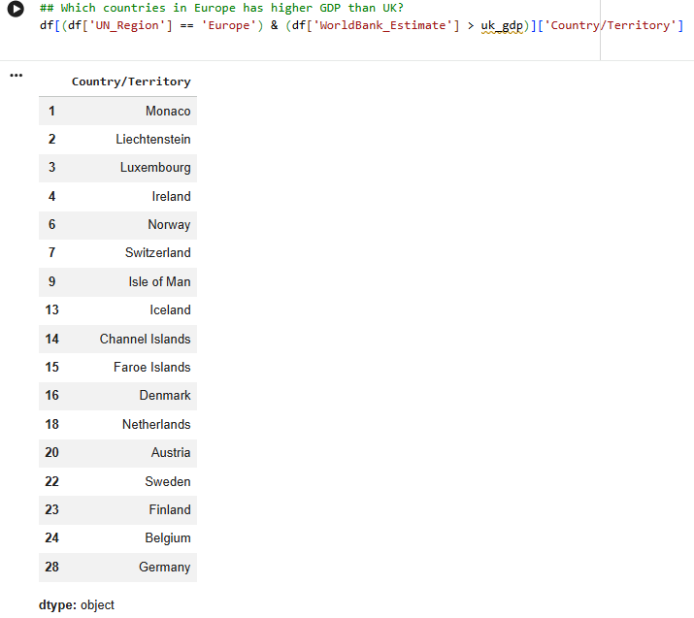

4.
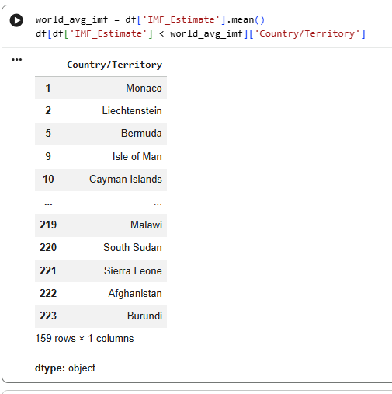

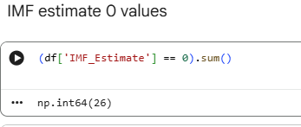
5.

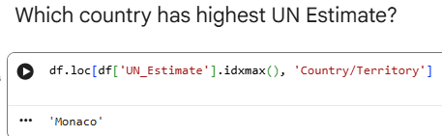
6.

7.
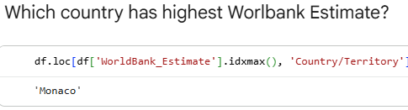

8.
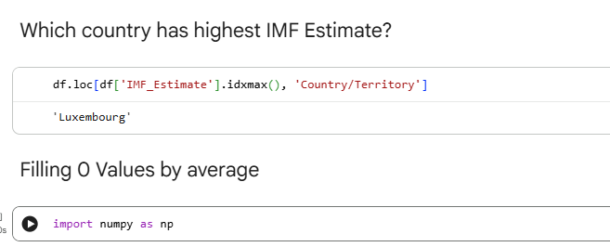

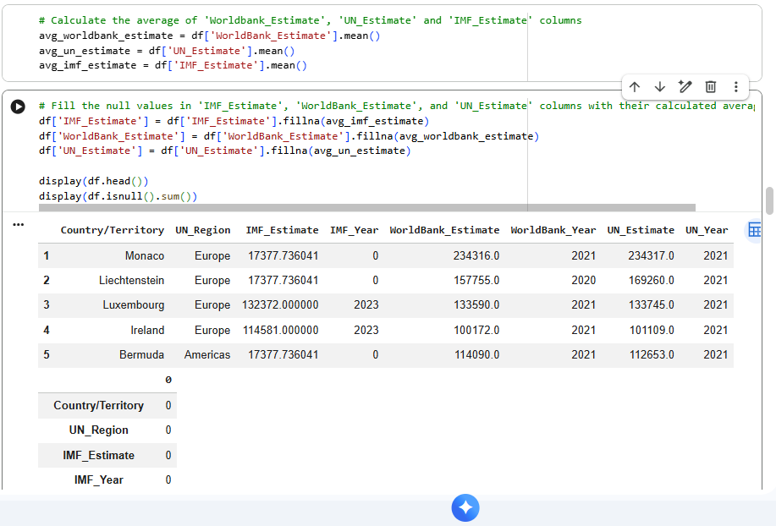
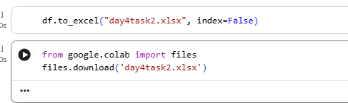

Course Notes

It is recommended to take notes from the course, use the space below to do so, or use the revision guide shared with the class:

Additional Information

We have included a range of additional links to further resources and information that you may find useful, these can be found within your revision guide.

END OF WORKBOOK

Please check through your work thoroughly before submitting and update the table of contents if required.

Please send your completed work booklet to your trainer.

